**条形码：**

[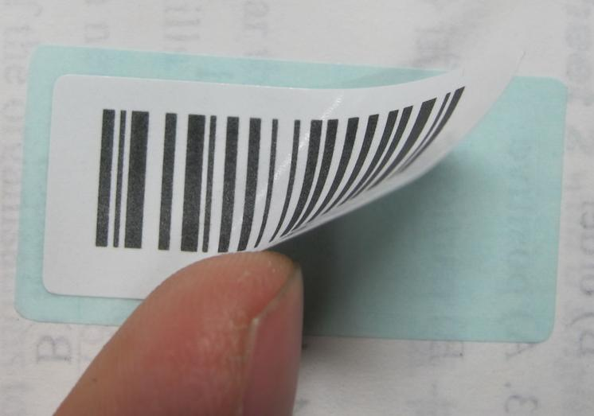](http://www.ahstu.edu.cn/wyxy/UploadFiles_8988/201212/2012120617222570.jpg)

**未粘贴条形码的答题卡：**

